Production-grade, modular Python AI Coding Agent that can clone or open GitHub and local repositories, inspect multi-language architectures, search symbols and code, plan solutions, request approval, safely edit files, run tests, analyze failures, and iteratively debug issues until tests pass

structure of the project :
ai-coding-agent/
│
├── main.py # CLI entry point (rich colored tables, diffs, report)
├── config.py # Configuration loader (.env, LLM keys, timeouts)
├── requirements.txt # Dependencies (pydantic, rich, openai, pytest, etc.)
├── .env.example # Template environment configuration file
├── README.md # Comprehensive documentation and quickstart guide
│
├── agent/ # Core Agent Subsystems
│ ├── __init__.py
│ ├── agent.py # Autonomous 16-step orchestrator
│ ├── llm.py # Pluggable LLM interface (OpenAI, local models, mock)
│ ├── repository.py # Git cloner & multi-language project scanner
│ ├── search.py # Ripgrep integration & Python regex symbol search
│ ├── terminal.py # Sandboxed command execution & safety guards
│ ├── editor.py # Atomic file modification, diffs & rollback
│ ├── analyzer.py # Keyword extractor & high-signal context builder
│ ├── planner.py # Structured implementation plan generator
│ ├── approval.py # Interactive & auto-approval handling
│ ├── tester.py # Test execution (pytest, cargo, npm, go, mvn, etc.)
│ └── debugger.py # Iterative self-healing debug & patch loop
│
├── models/ # Data Schemas
│ ├── __init__.py
│ └── schemas.py # Pydantic schemas (RepoInfo, Plan, FileChange, etc.)
│
├── workspace/ # Workspace Directory
│ └── repositories/ # Cloned repositories directory (.gitkeep)
│
└── tests/ # Full Automated Test Suite (100% Pass)
├── __init__.py
├── test_terminal.py # Terminal sandbox and timeout tests
├── test_repository.py # Multi-language detection tests
├── test_search.py # Symbol and reference search tests
├── test_editor.py # File modification and path traversal tests
├── test_tester.py # Test result parsing tests
├── test_debugger.py # Debug repair loop tests
└── test_e2e_agent.py # End-to-end bug fixing integration tests

To run the project we just need to give the link of the repository and give the following command.
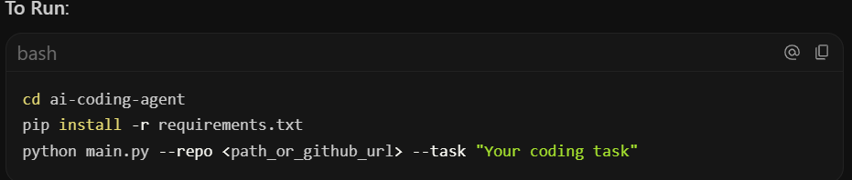
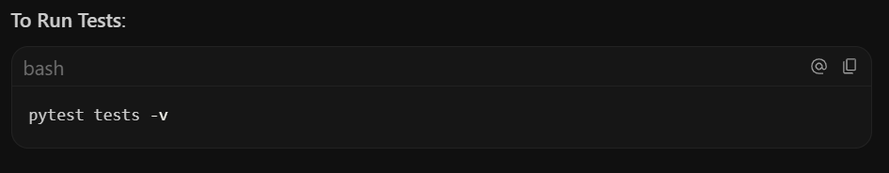

1. Runtime & Environment
Component | Version / Specification | Role in Project
Python | 3.11+ (Verified on Python 3.12.10) | Primary programming language
Git | 2.55+ (MinGit Portable on Windows) | Repository cloning, branch tracking, diffs, and commit history
Operating System Support | Windows, Linux, macOS | Cross-platform compatibility (handles Windows paths, PowerShell/CMD, and POSIX shells)

2. External Dependencies (requirements.txt)
Package | Version | Purpose & Usage
pydantic | >= 2.0.0 | Data Modeling & Validation: Defines strict, type-safe schemas for repository metadata (RepoInfo), search matches (SearchMatch), implementation plans (Plan, PlanStep), diffs (FileChange), test results (TestResult), and debug iterations (DebugIteration).
rich | >= 13.0.0 | Terminal User Interface (TUI): Renders colored status panels, repository property tables, test verification history tables, and syntax-highlighted unified diffs in the terminal.
openai | >= 1.20.0 | Official LLM SDK: Integrates with OpenAI models (gpt-4o, gpt-4o-mini) as well as any OpenAI-compatible provider (Ollama, vLLM, DeepSeek, Groq, OpenRouter) via custom LLM_BASE_URL.
python-dotenv | >= 1.0.0 | Configuration: Loads environment variables automatically from .env files for seamless configuration without exposing secrets.
pytest | >= 8.0.0 | Automated Testing: Framework used to run the comprehensive unit and end-to-end test suite across all agent modules.

3. Key Python Standard Libraries Used
No unnecessary external dependencies were added; the agent heavily leverages Python's built-in standard library:
- subprocess: Safe process execution for running shell commands, git operations, and test suites with custom environment variables and timeouts.
- difflib: Generates unified git-style diffs (difflib.unified_diff) between original and modified code for user review.
- pathlib.Path: Object-oriented path resolution and sandboxing (ensures file operations and terminal executions never escape the repository root).
- re: High-performance regular expression parsing for language-aware symbol definitions (def, class, fn, func, struct), test failure extraction, and JSON response sanitization.
- shutil: Detects system binaries (e.g., checking if rg / ripgrep is installed on the user's system via shutil.which).
- fnmatch: Glob pattern matching for file searching (e.g., *test*.py, *.rs).
- time: Accurate command duration benchmarking via time.perf_counter() and timeout enforcement.
- dataclasses: Lightweight data containers for configuration settings.

4. Architectural Modules & What They Do
The project follows a modular, single-responsibility architecture:
ai-coding-agent/
├── config.py # Configuration manager (reads .env, timeouts, auto-approve flags)
├── main.py # CLI entry point with Rich terminal UI and argument parser
├── models/
│ └── schemas.py # 10+ Pydantic models guaranteeing type safety across the system
└── agent/
├── llm.py # Pluggable LLM interface + OpenAI + MockLLM for offline testability
├── repository.py # Git cloning, language/build system/test runner detection across 8+ languages
├── search.py # Dual search engine: Ripgrep CLI + Python regex fallback crawler
├── terminal.py # Sandboxed command runner with timeouts and destructive command blocklist
├── editor.py # Atomic file editing, path traversal prevention, and unified diff generator
├── analyzer.py # Task keyword & domain synonym extractor, token-efficient context builder
├── planner.py # Formulates structured, step-by-step implementation plans from LLM
├── approval.py # Interactive user approval gate ([A]pprove / [R]eject) & CI auto-approve
├── tester.py # Multi-language test dispatcher and error parser (pytest, cargo, npm, go, mvn)
├── debugger.py # Self-healing iterative loop: failure analysis -> targeted fix -> re-test
└── agent.py # 16-step master orchestrator linking the entire software engineering loop

5. Specialized Design Patterns Implemented
- Pluggable Strategy Pattern (LLMClient):
  - Easily swap between OpenAI, local models (Ollama/vLLM), or the built-in MockLLMClient without changing agent logic.
- Repository Sandboxing & Safety Guard:
  - terminal.py and editor.py validate relative paths against the repository root to prevent path traversal attacks (../).
  - Destructive commands (such as rm -rf /, formatting commands, or fork bombs) are blocked.
- Context Optimization:
  - Rather than sending the entire repository to the LLM (which exceeds context windows and wastes tokens), analyzer.py searches keywords and domain synonyms (e.g. cart →→ checkout, price, item), extracting only the necessary snippets.
- Self-Healing Iterative Debugging:
  - When tests fail, debugger.py analyzes the exact traceback and runs up to MAX_DEBUG_ITERATIONS to formulate targeted edits and re-verify until the test suite passes.

6. Summary of Test Coverage (tests/)
The project includes 12 automated tests covering every tool:
- test_terminal.py: Validates basic execution, directory isolation, safety blocking, and timeout handling.
- test_repository.py: Validates multi-language detection across Python, Rust, JavaScript, and toolchains.
- test_search.py: Validates literal search, file pattern matching, symbol extraction, and cross-references.
- test_editor.py: Validates atomic writes, text replacement, diffing, rollback, and traversal security.
- test_tester.py: Validates output parsing for both pytest and cargo test.
- test_debugger.py: Validates the automated repair and re-verification loop.
- test_e2e_agent.py: An end-to-end integration test that creates a real Git repository with a failing calculation, runs the full autonomous agent, applies fixes, and verifies a 100% passing test result.

